

**COMP6231- Distributed System Design**

**Assigment-1**

Distributed Player Status System (DPSS) using Java RMI

**Date:** 07 June 2020.

**Recipient:** Prof. Mohammed Taleb

**Student Name:** Raj Mistry (40119206)

* **Objective:**

The main objective is to design and implement a Distributed Player Status System which manages player’s status across multiple game server. Java RMI offers simple way to call different methods on server machines to perform various operation and returning objects over network and provide network transparency. Use of multi-threading with proper synchronization to handle concurrent requests with ease. User Datagram Protocol is used by servers to interact between each other, sending and receiving requests to perform inter-server operations. UDP is highly reliable so as the connection between the server is not easily sabotaged.

* **Design Architecture:**

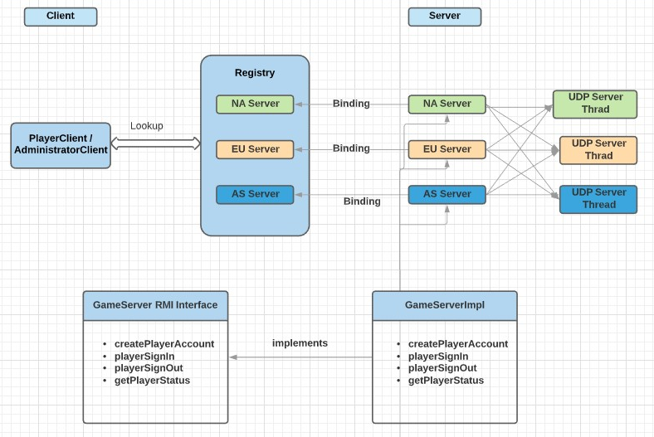

* **Implementation:**
* ***Main Components:***
* RMI Registry
* Interface (GameServer Interface)
* Server (NA, EU, AS)
* UDP Server
* RMI Registry:
* The three instances of GameServerImpl has been binded to the registry with three different names i.e. exposing the server objects to client.

e.g. registry.bind(“NA”, naServer) is used to bind the registry for North-America

Server.

* RMI Interface: (GameServer.java)
* createPlayerAccount(String firstName,String lastName,String age,String username,String password,String ipAddress)
* playerSignIn(String username,String password)
* playerSignOut(String username)
* getPlayerStatus()
* RMI Server: (GameServerImpl.java)
* This class implements the GameServer interface.
* Three instances of RMI game server implementation has been created. One for each geo-location (NAServer.java, EUServer.java, ASServer.java).
* Model
* Player.java
* This class is used to store player account information like username, password, first name, last name, etc.
* ***HashTable Implementation:***
* Here, HashTable is used as database for player accounts and it allows us to perform various operations like creating new account, getting player status and setting player status. Hash function is used to link key value pair. And key is taken as username’s first character i.e. all player accounts whose username starts with “A” stores to same list and mapped to key “A”.
* ***UDP Server Design:***
* The communication between the servers is done by UDP to fetch the player status from each of the servers and display them. The get status each server will fork and get the count request thread to remaining servers. Communication among to all three servers take place using UDP/IP protocol.

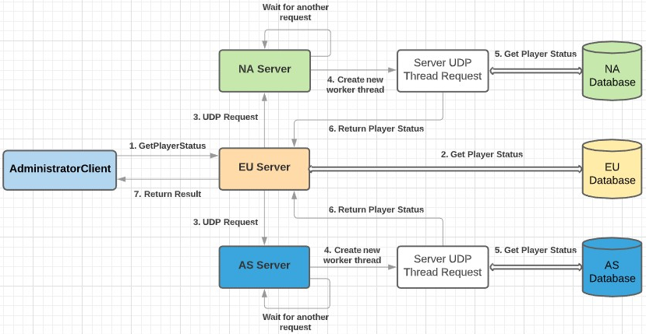

**\* Execution Flow \***

* **Challenges:**

This is the first time I’ve developed a distributed application and faced many challenges during the development. Following are few of the challenges I faced:

1. RMI implementation
2. HashTable for Storing Player accounts
3. UDP communication between servers
4. Concurrency
5. Making logs for client and servers

* **Test Cases:**

1. **Validations (All attributes must be entered & can’t be empty)**

* First Name and Last Name Should Contain Only Alphabets without any Whitespaces.

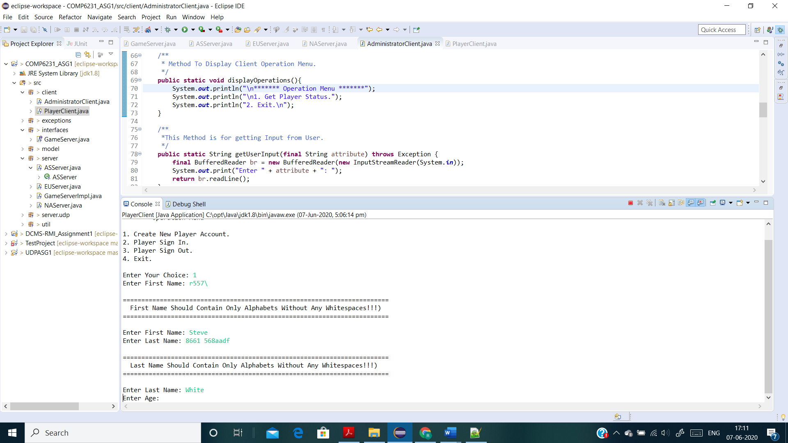

* Age must be Positive Integer without any whitespaces.

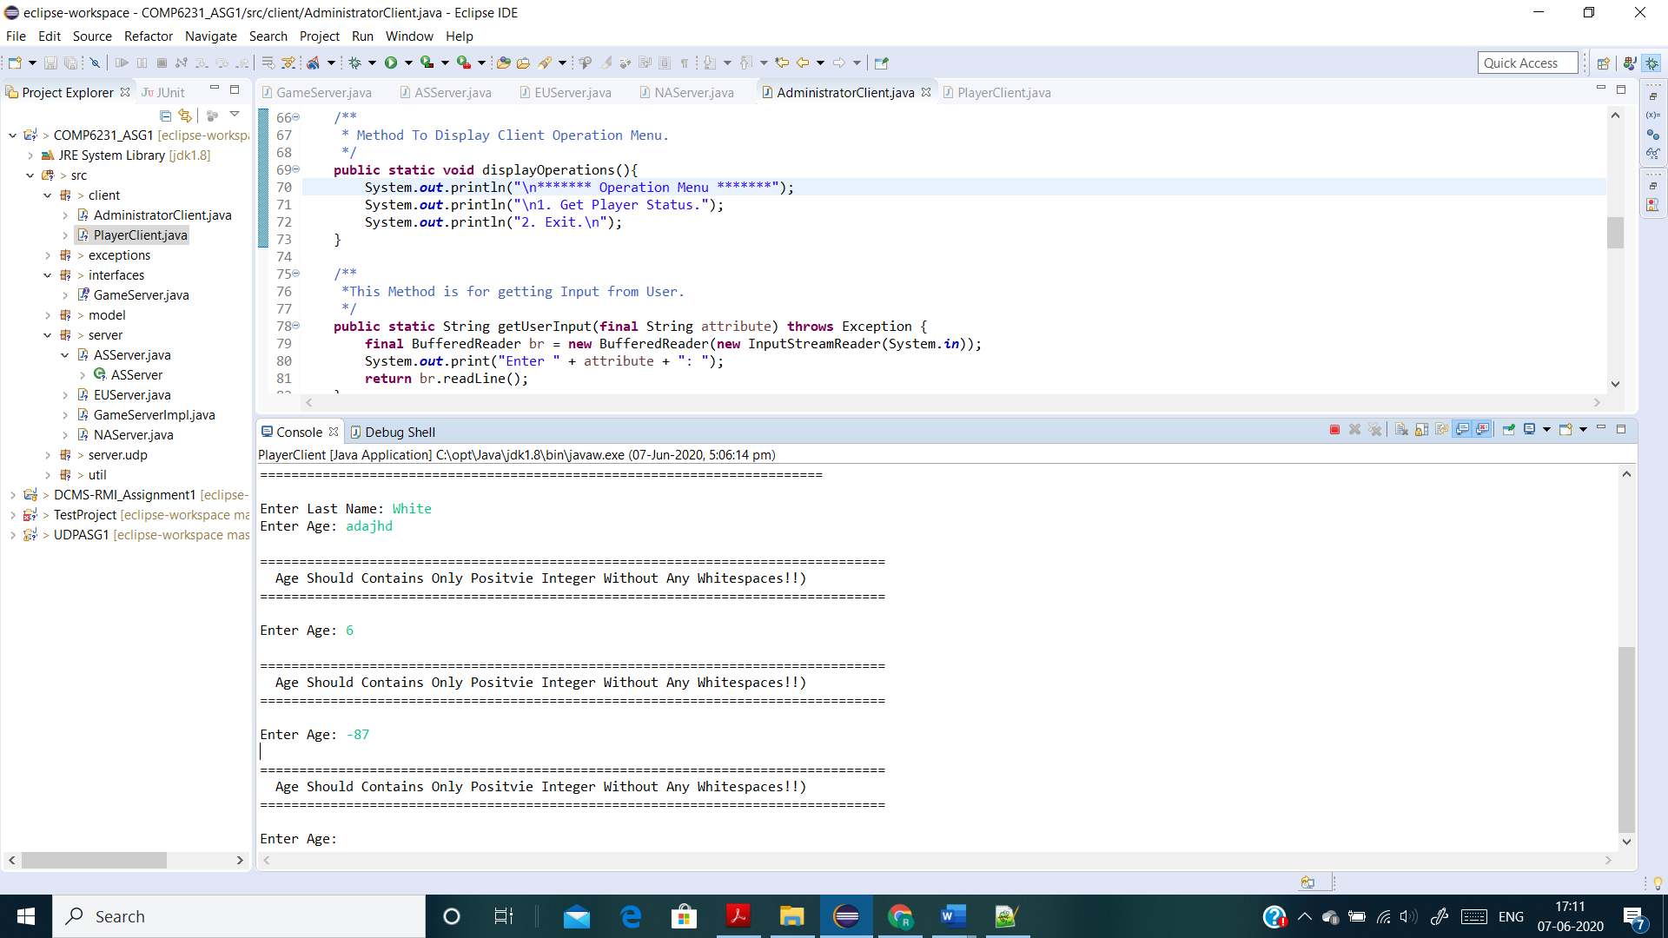

* Username must be start with alphabet and should not contain any whitespaces and length must be minimum of 6 and maximum of 15 characters.

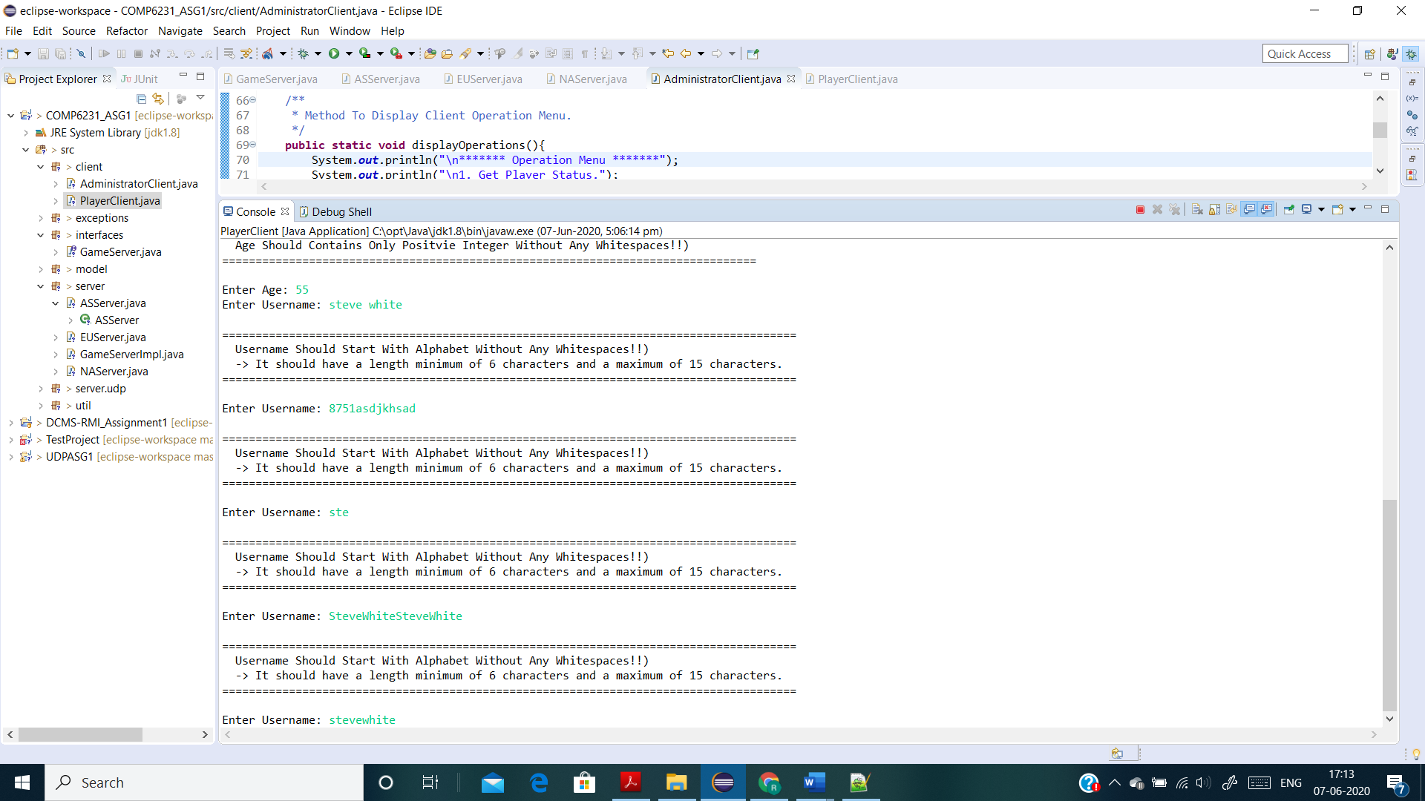

* Password must not contain any whitespaces and should have minimum length of 6 characters.

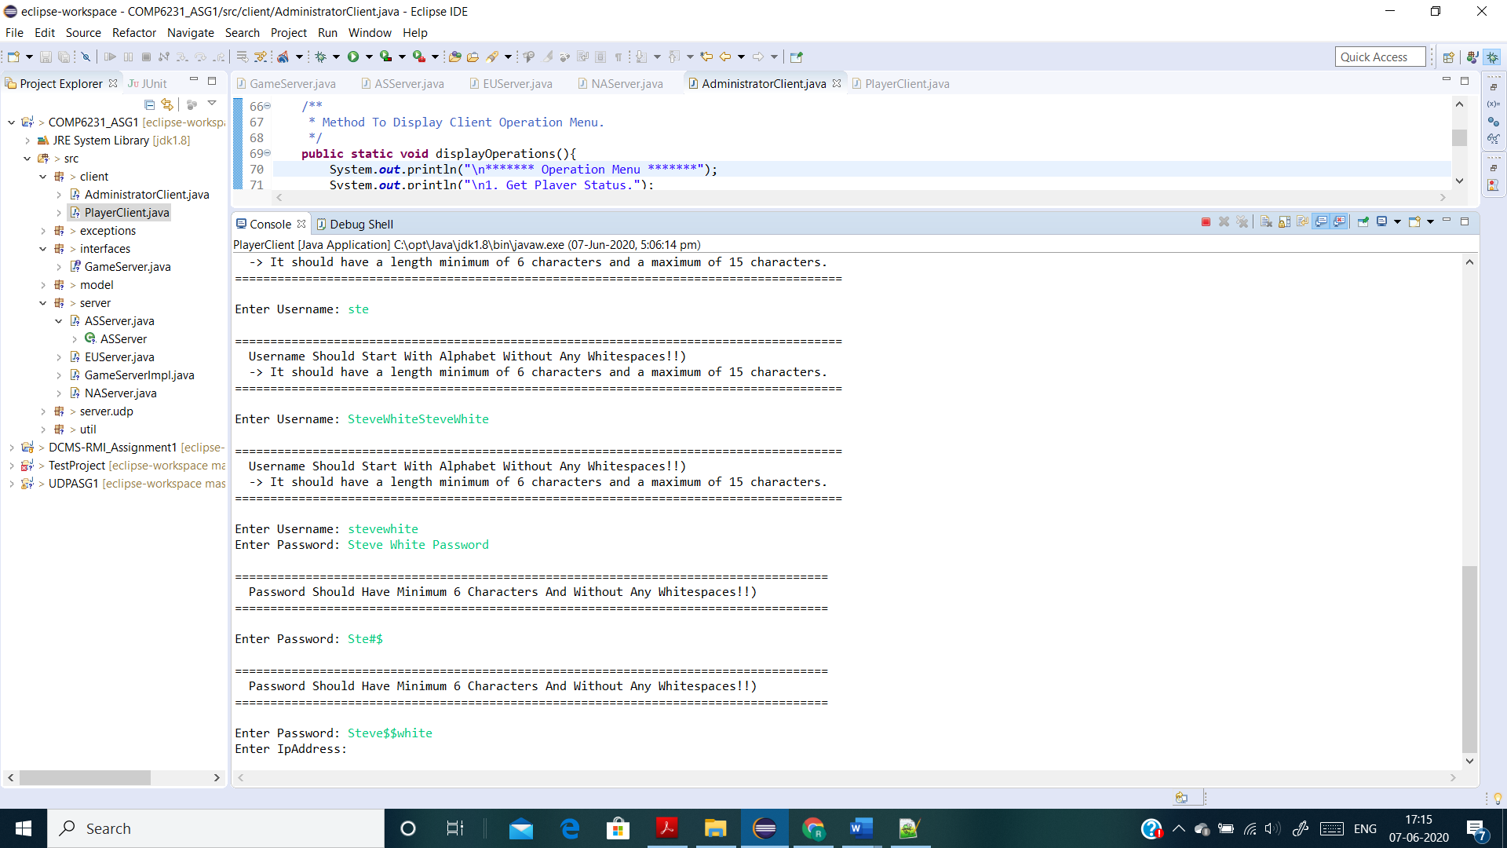

* IP Address must be entered as per valid IPv4 format & must be entered from one of the 3 ranges (132.xxx.xxx.xxx, 93.xxx.xxx.xxx, 182.xxx.xxx.xxx)

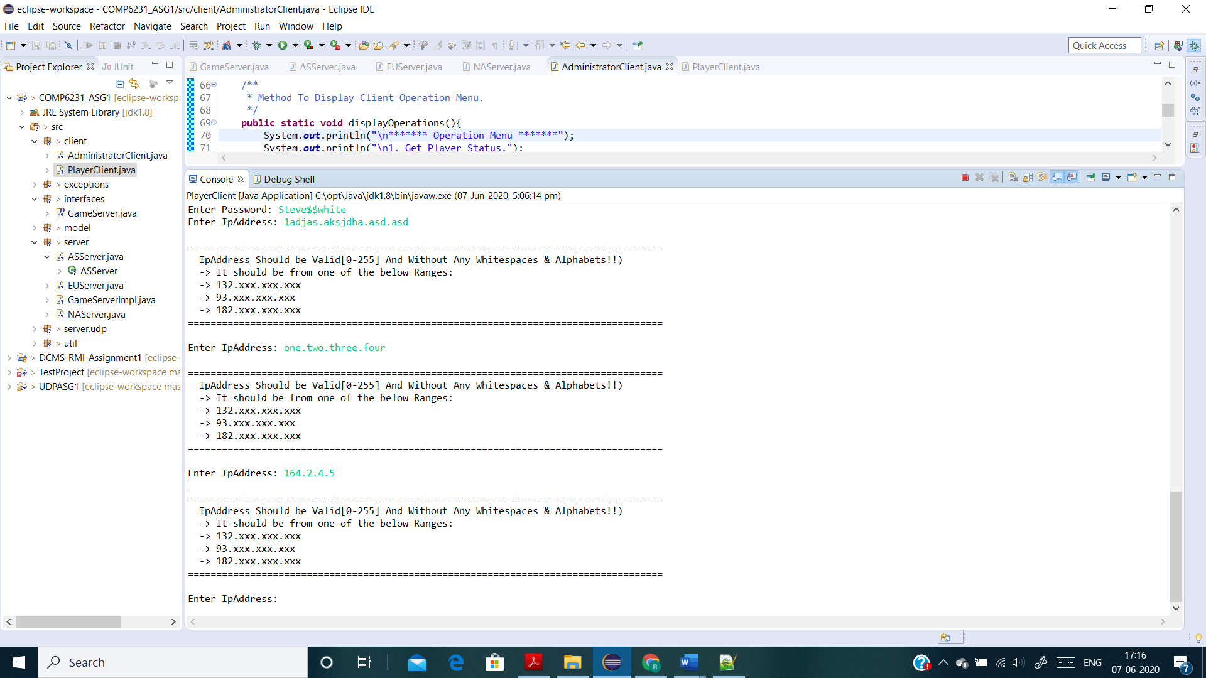

* Username and Password for Administrator must be “Admin” without any whitespaces and must be exact same as shown (Case Sensitive).

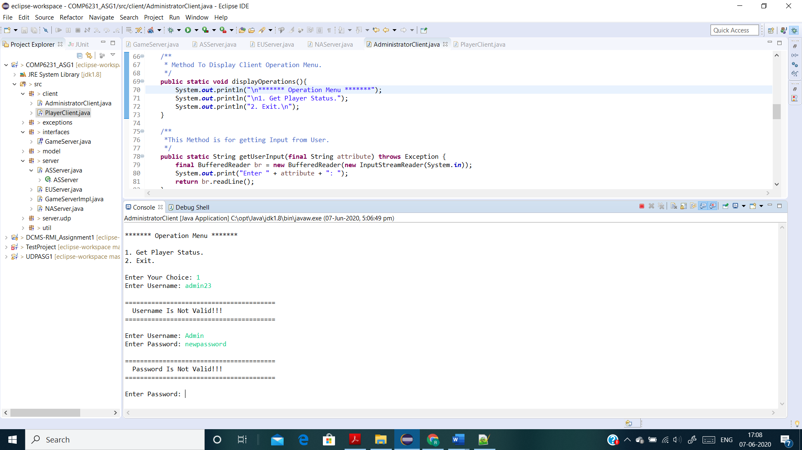

1. **Create New Player Account (Successful)**

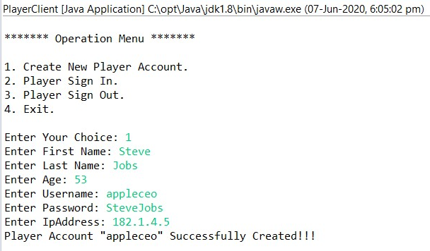

1. **Create New Player Account (Unsuccessful – Player Account Already Exist)**

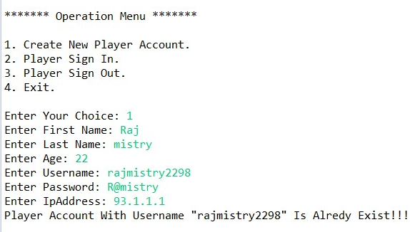

1. **Player Sign In (Player Not Exist)**

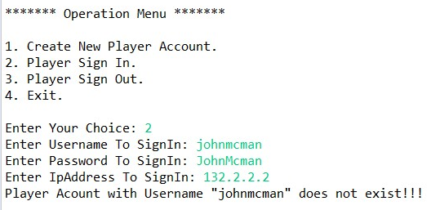

1. **Player Sign In (Wrong Password Entered For Sign In)**

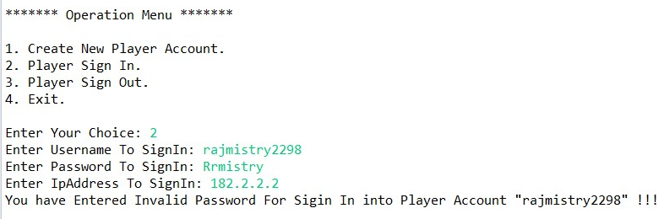

1. **Player Sign In (Successfully Signed In)**

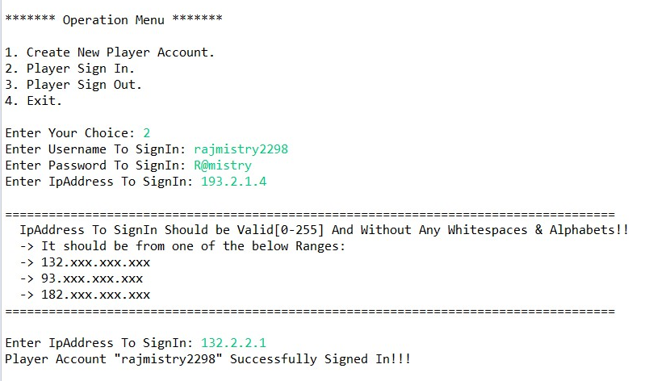



1. **Player Sign In (Already Signed In)**

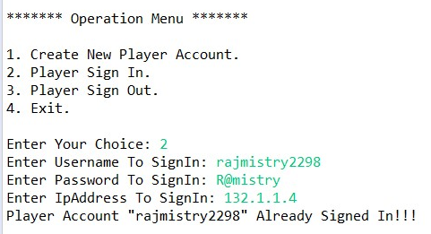

1. **Player Sign Out (Player Not Exist)**

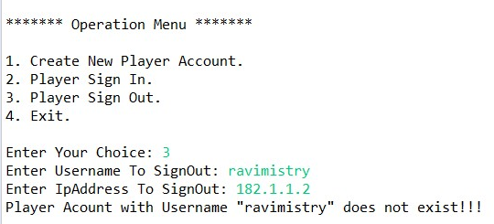

1. **Player Sign Out (Successfully Signed Out)**

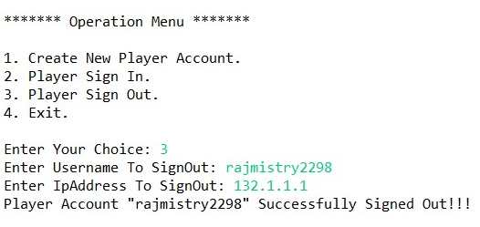

1. **Player Sign Out (Already Signed Out)**

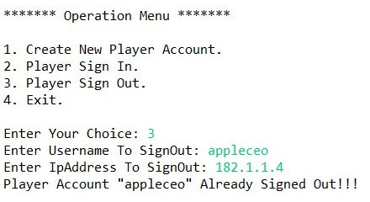

1. **Administrator Get Player Status**

**Initially each server has 3 accounts:**

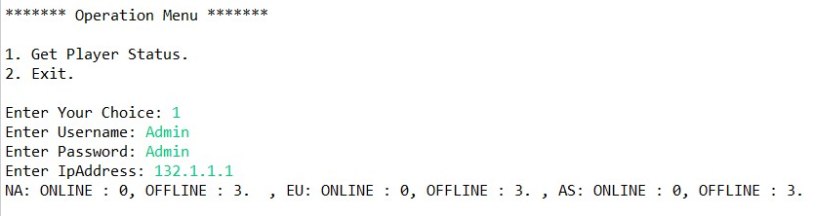

**After Creating One Account:**

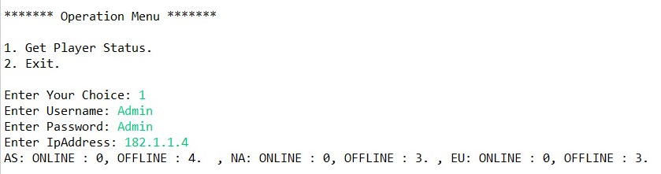

**One Player Signed In:**

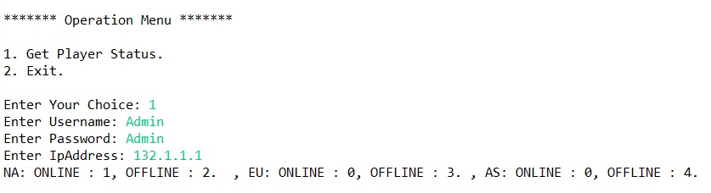

* **References:**

+ <https://www.mkyong.com/java/java-rmi-distributed-objects-example>

+ <https://docs.oracle.com/javase/7/docs/technotes/guides/rmi/>

+[http://www.ejbtutorial.com/java-rmi/new-easy-tutorial-for-java-rmi- using-eclipse](http://www.ejbtutorial.com/java-rmi/new-easy-tutorial-for-java-rmi-%20%20using-eclipse)

+<https://stackoverflow.com/questions/2836646/java-serializable-object-to-byte-array>

+<https://mkyong.com/regular-expressions/how-to-validate-ip-address-with-regular-expression/>

+ <https://www.tutorialspoint.com/java_rmi/java_rmi_application.htm>

+<https://www.geeksforgeeks.org/working-udp-datagramsockets-java/#:~:text=DatagramSockets%20are%20Java's%20mechanism%20for,receive%20packets%20over%20the%20Internet.>